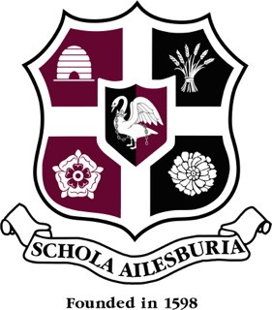
AYLESBURY GRAMMAR SCHOOL
FOOD TECHNICIAN
PERSON SPECIFICATION

Qualifications  Educated to GCSE level (or equivalent) in Science, Maths and English  Good practical and technical skills  Previous experience in a similar environment  An awareness of Food Hygiene & Health and Safety issues. Food Hygiene Certificate level 2 | Essential or desirable  Essential  Essential  Desirable  Essential – training will be provided

Knowledge and skills  A passion for Food and Cooking and issues around healthy eating  Excellent organisational skills and ability to meet deadlines  Good communication skills and able to work independently within a team setting  Accuracy and attention to detail when following procedures  Ability to clean and maintain equipment and keep records | Essential  Essential  Essential  Essential  Essential

Experience  Working with children or in a teaching capacity | Desirable

Personal skills  Flexible and adaptable with a ‘can do’ attitude  Approachable and confident to work alongside staff and students | Essential  Essential

