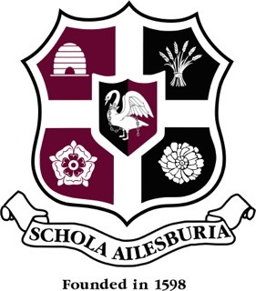
AYLESBURY GRAMMAR SCHOOL
IT INFRASTRUCTURE SPECIALIST
PERSON SPECIFICATION

 | Essential | Desirable
Qualifications | GCSE A*-C in English and Maths | Any relevant IT qualifications
Previous Work Experience | Background in IT/ICT
Professional Skills & Experience | Excellent knowledge and familiarity of software, hardware, Operating Systems, Active Directory environments, virtualisation, printers, servers, cloud computing, networking, G-Suite and Office 365.  The ability to manage maintenance and repair procedures.  The ability to assess and prioritize issues  The ability to install, test and maintain hardware and software. | Previous experience of working in an educational environment  Familiarity with iSAMS  Knowledge of educational software and hardware  Ability to provide training to colleagues  Ability to evaluate new technologies
Other Personal Qualities | Passion for IT, keeping up to date with latest developments and applying that knowledge.  A commitment to the safeguarding and welfare of young people.  A willingness to learn new skills and technologies.  The ability to solve problems and make decisions remaining calm under pressure.  The ability to work flexibly and supportively with staff and students  The ability to communicate clearly and effectively, and to understand the view of others

March 2019

